
NAME: RACHITHA.R
REG-NO: 192421058
SUBJECT: COMPUTER VISION FOR IMAGE SEGMENTATION
SUBJECT-CODE: ITA0528
EXPERIMENT -01
Convert image to gray-image.
Code:
import cv2
img = cv2.imread('sample.jpg')
gray = cv2.cvtColor(img, cv2.COLOR_BGR2GRAY)
cv2.imshow("Original Image", img)
cv2.imshow("Gray Image", gray)
cv2.waitKey(0)
cv2.destroyAllWindows()
Input:
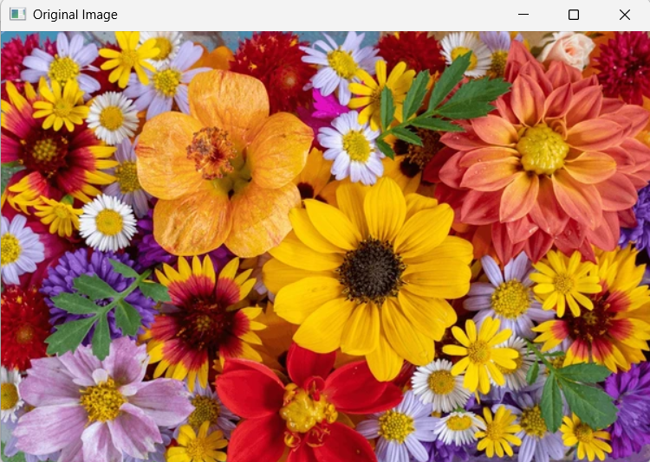
Output:
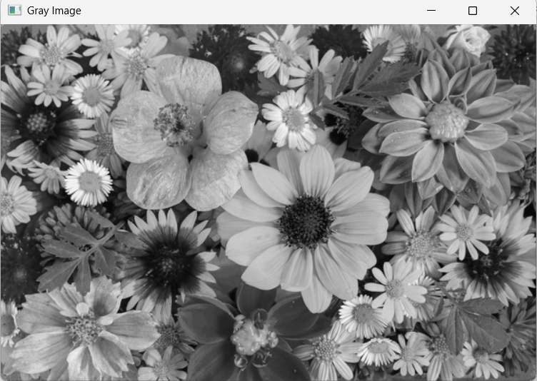

EXPERIMENT – 02
Code:
import cv2
img = cv2.imread('sample.jpg')
blur = cv2.GaussianBlur(img, (5,5), 0)
cv2.imshow("Original Image", img)
cv2.imshow("Blur Image", blur)
cv2.waitKey(0)
cv2.destroyAllWindows()
input:
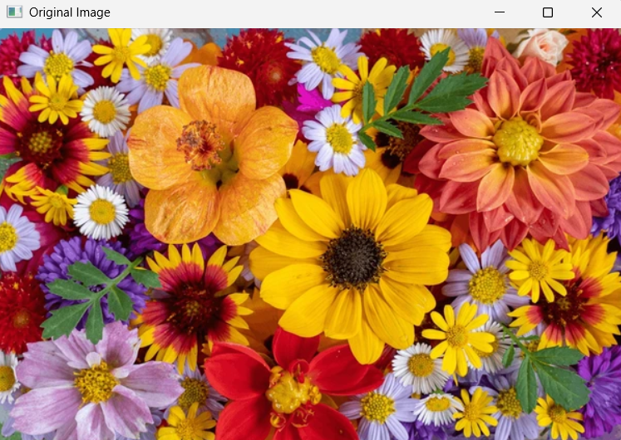
Output:
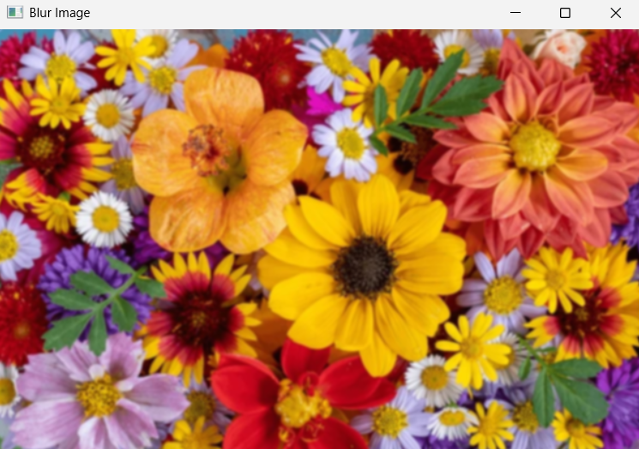

EXPERIMENT – 03
Code:
import cv2
img = cv2.imread('sample.jpg')
gray = cv2.cvtColor(img, cv2.COLOR_BGR2GRAY)
edges = cv2.Canny(gray, 100, 200)
cv2.imshow("Original Image", img)
cv2.imshow("Edge Image", edges)
cv2.waitKey(0)
cv2.destroyAllWindows()
Input:
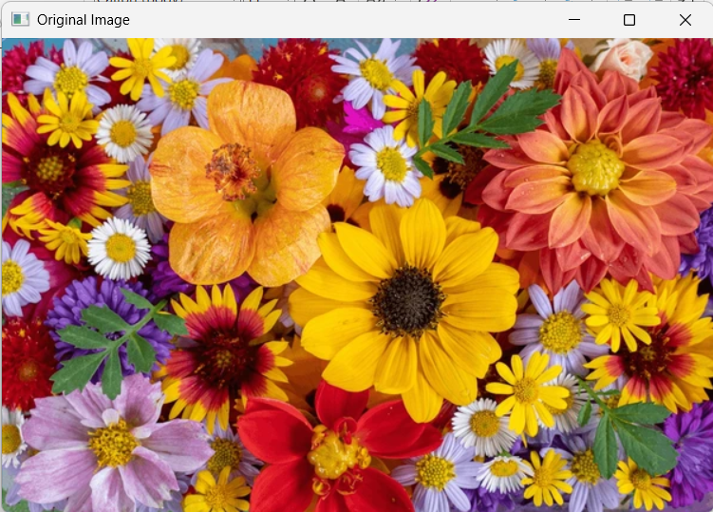
Output:
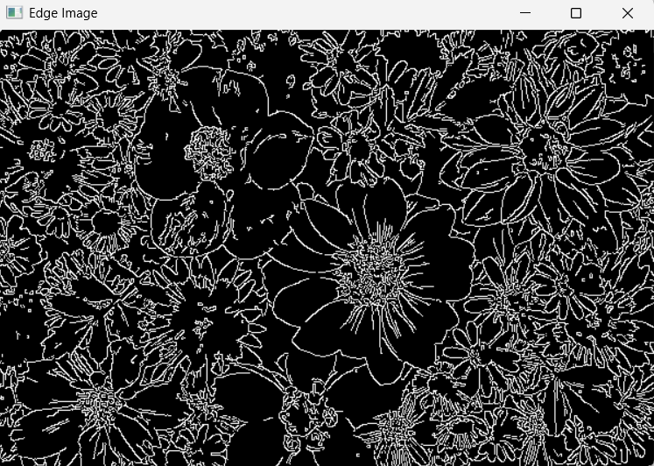

EXPERIMENT – 04
Code:
import cv2
img = cv2.imread('sample.jpg')
gray = cv2.cvtColor(img, cv2.COLOR_BGR2GRAY)
equalized = cv2.equalizeHist(gray)
cv2.imshow("Original Gray", gray)
cv2.imshow("Equalized Image", equalized)
cv2.waitKey(0)
cv2.destroyAllWindows()

Input:
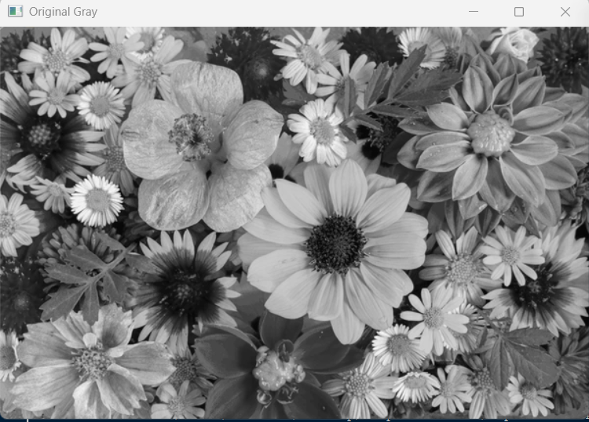
Output:
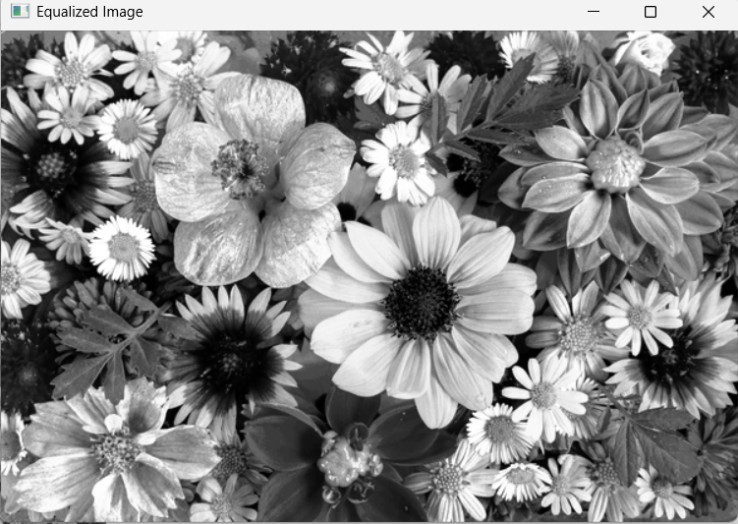

EXPERIMENT -05
Code:
import cv2
import matplotlib.pyplot as plt
img = cv2.imread('sample.jpg')
colors = ('b', 'g', 'r')
for i, col in enumerate(colors):
hist = cv2.calcHist([img], [i], None, [256], [0,256])
plt.plot(hist, color=col)
plt.title("Color Histogram")
plt.xlabel("Pixel Intensity")
plt.ylabel("Frequency")
plt.show()
Input:
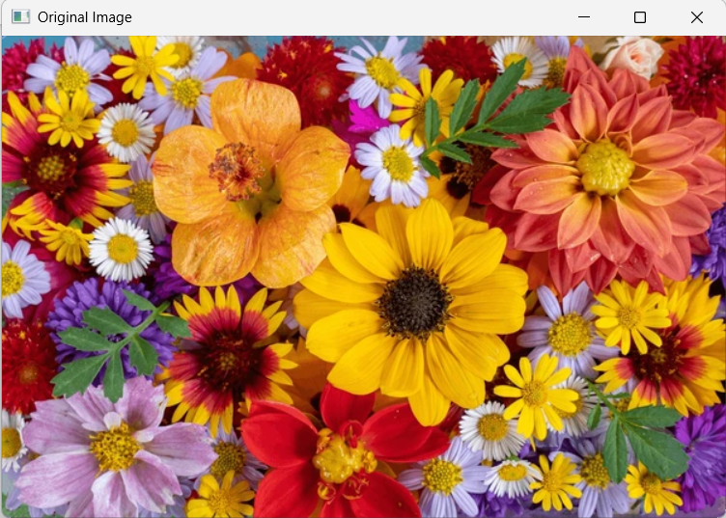

Output:
